PROJECT RISK MANAGEMENT
A lot of people ask us what is Risk Management and how often we do it. Risk refers to uncertainty. This risk can be positive or negative. Every project, business, and investment done by an organization will have certain kinds of risks involved. These risks need to be managed. If the risk is not managed properly it will have a positive or negative impact.
Project Risk Management includes the processes of conduction risk management planning, identification, analysis, response planning, response implementation, and monitoring risk on a project.
Triple Constrains
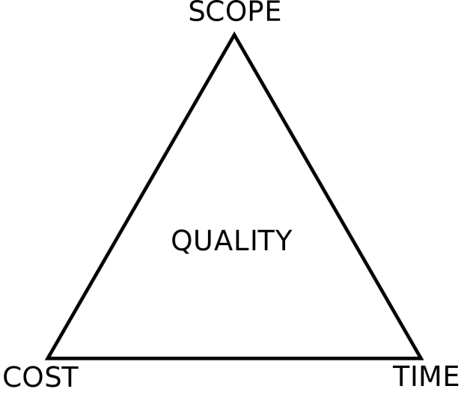
The triple constraint in Risk Management says every project operates within the boundaries of scope, time, and cost (also quality). A change in any of the factors will invariably affect the other two.
Cost: The financial constraints of a project, also known as the project budget
Scope: The tasks required to fulfill the project’s goals
Time: The schedule for the project to reach completion
Project risk management is often a series of trade-offs and compromises to keep things moving towards successful completion. The Triple Constraint is a model that helps managers know what trade-offs are going to work and what impact they'll have on other aspects of the project.
Risk Management
Risk Management Plan is a subset, or a sub-plan, of the Project Management Plan. Basically, what is detailed in the Project Risk Management Plan is the process. This process is the question of who, what, when, and how. Who needs to know? Who can inject risk into the project? What’s the process? When do we do it? How do we do it?
We also look at tools. We identify what toolset we're going to use, so everyone on the project who needs
to know, or is involved, will know what tools to use. This can be project management software, Microsoft Excel, Templates, etc.

Process Involved in Project Risk Management
Basically, it’s just all the activities that we use to manage the risk throughout the project. These activities are listed below:
- Plan Risk Management
Plan risk management process defines how to conduct risk management activities for a project. Plan risk management helps in ensuring that the degree, type, and visibility of risk management are proportionate to both risks and the importance of the project to the organization and other stakeholders. It’s performed one or at the predefined points in the project lifecycle
- Identify Risks
The risk identification process is to identify the individual project risks as well as sources of overall project risk and documenting their characteristics. This process helps in documenting the existing individual project risks and the sources of overall project risk. It also helps in bringing together the information using which the project team can respond appropriately to identified risks.
- Perform Qualitative Risk Analysis
This process prioritizes the individual project risks for further analysis or action by assessing their probability of occurrence and impact as well as other characteristics. The major benefit of this process is that it focuses efforts on high-priority risks. This process is performed regularly throughout the project life cycle.
- Plan Risk Response
This process numerically analyzes the combined effect of identified individual project risks and other sources of uncertainty on overall project objectives. The main benefits of this process are that it quantifies overall project risk exposure and it can also provide additional quantitative risk information to support risk response planning. The process is not required for every project, but where it is used it is performed throughout the project.
- Implement Risk Responses
This process helps in developing options selection strategies and agreeing on action to address overall project risk exposure as well as to treat individual project risks. It also identifies appropriate ways to address overall project risk and individual project risks. This process also allocated resources and inserts activities into project documents and the project management plan as needed.
- Monitor Risks
This process helps in implementing risk response plans. The main benefit of this process is to ensure that risk responses are executed as planned in order to address overall project risk exposure, minimize individual project threats, and maximize individual project opportunities. This process is performed throughout the project.

